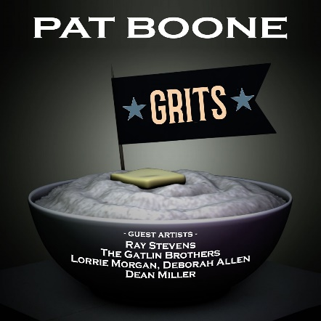

Bringing Some Glamour To Grits:
As He Celebrates 70 Years in Show Business, Legendary Singer Pat Boone
Teams up with Country Icons for"Grits" Release – Due out April 7

Boone Brings Together Deborah Allen, The Gatlin Brothers, Dean Miller,
Lorrie Morgan, and Ray Stevens in Unique Collaboration

FOR IMMEDIATE RELEASE (Nashville, TN – March 24, 2023) Legendary singer, actor, songwriter, and author Pat Boone has teamed up with some of the most beloved artists in country music for his latest release, "Grits," https://orcd.co/ejedr90 due out April 7, 2023 on all streaming and download platforms via The Gold Label/The Orchard. Boone, 88, who has sold over 45 million records worldwide and had 38 Top 40 hits, is reconnecting with his Nashville roots with this true-blue country novelty song.

Written by Boone and produced by Jimmy Nichols and Frank Myers, “Grits” is a high-energy song, with line dancing written all over it, featuring country music stars Ray Stevens, The Gatlin Brothers, Lorrie Morgan, Deborah Allen, and country legend Roger Miller's son, Dean Miller.

"Grits" is an ode to the Southern food staple, praising its superiority over other fancy foods such as escargot and pâté. The catchy chorus expresses gratitude for growing up in the country and enjoying hearty dishes like turnip greens and black-eyed peas, with the singer insisting that nothing beats the satisfaction of a warm bowl of grits.

"I've had a life-long love of grits," Boone said. "Breakfast, lunch, and dinner. With this song, I wanted to celebrate the simple joys of Southern cuisine and pay homage to the roots that shaped my music career."

Boone runs his own record company, The Gold Label, designed for legendary artists with certifiable talent, all with million-selling gold records to their credit. Debby Boone, Glen Campbell, Jack Jones, Cleo Laine, Patti Page, Sha Na Na, The Ventures, Roger Williams, and others (as well as Boone himself) all lived up to the Founder's Maxim. More than 30 Gold Label albums have been released to date, and the label is now 20 years old.

Pat Boone is a legendary American singer, actor, and television personality who rose to fame in the 1950s, after winning TV’s first national talent contest, with his smooth, wholesome style of music. He is also known for his starring roles in over a dozen major Hollywood studio films, such as "April Love" and "State Fair," and more recently, “The Mulligan,” which Boone just took home the Grace Award for Most Uplifting Performance In Movies at the Movieguide Awards in Hollywood. Now celebrating the 70th anniversary of his career in show business, Boone is the weekly host of his own SiriusXM radio show, “The Pat Boone Hour,” and is continuing a book tour promoting “IF-The Eternal Choice We All Must Make,” (his 28th).

For more information, please contact [contact information].

Contact:
Christy Walker-Watkins – AristoPR – christy@aristomedia.com – 615-269-7071
FOR PAT BOONE: Jerry Digney –DIGNEY & Co., jerry@digneypr.com c.818 693 1087

