FOR IMMEDIATE RELEASE

Singer and Songwriter Pat Boone Collaborates With Country Music Singer Crystal Gayle on New Music Video “You And I,” Dedicated to Boone’s Late Wife

https://www.youtube.com/watch?v=bLXeIv9KaSI

(Nashville, Tennessee – August 29, 2023) Celebrated singer Pat Boone has joined forces with Country singer Crystal Gayle, releasing a new music video of the 1982 Billboard #1 hit duet, “You And I.” The video is now available to watch here.

The video is dedicated to Boone’s late wife, Shirley, who passed away in early 2019. The touching track, originally recorded by Gayle and Eddie Rabbitt, reminisces on the past life a couple shared together, through first embraces and promises made that they would forever share love. Looking back on all the memories, they realize they flourished together, just the two of them.

Boone comments on the release of the video, saying “It gives me great joy to be able to have Crystal on the track with me. This song means so much, as I know Shirley is in Heaven. I will see her again, and we will be together forever.”

“You And I” is one of the 25 tracks featured on Boone’s upcoming album project, Country Jubilee, to be released on September 8. The album proudly presents five of Boone's Top 100 Country recordings, allowing fans to relive some of his most cherished performances.

Another track on the anticipated album is Boone’s newest hit song, “Grits.” This foot-stomping, heartwarming song is an ode to Southern traditions, embracing the spirit of camaraderie and joy that defines the Country music experience. Adding to the excitement, "Grits" features an ensemble of esteemed guest artists, including Ray Stevens, The Gatlin Brothers, Lorrie Morgan, Deborah Allen, and Dean Miller. The official music video for “Grits” can be viewed here.

Pat Boone is a legendary American singer, songwriter, actor, author, and television personality who rose to fame in the 1950s, after winning TV’s first national talent contest, with his smooth, wholesome style of music. He is also known for his starring roles in 26 movies, such as “April Love” and “State Fair,” and more recently, “The Mulligan,” in which Boone just took home the Grace Award for Most Uplifting Performance In Movies at the Movieguide Awards in Hollywood. Now celebrating the 70th anniversary of his career in show business, Boone is the weekly host of his own hit SiriusXM radio show, “The Pat Boone Hour,” and is continuing a book tour promoting “IF-The Eternal Choice We All Must Make,” (his 28th).

For more information about Pat Boone, visit his website and follow him on Instagram, Facebook, Twitter, and YouTube.

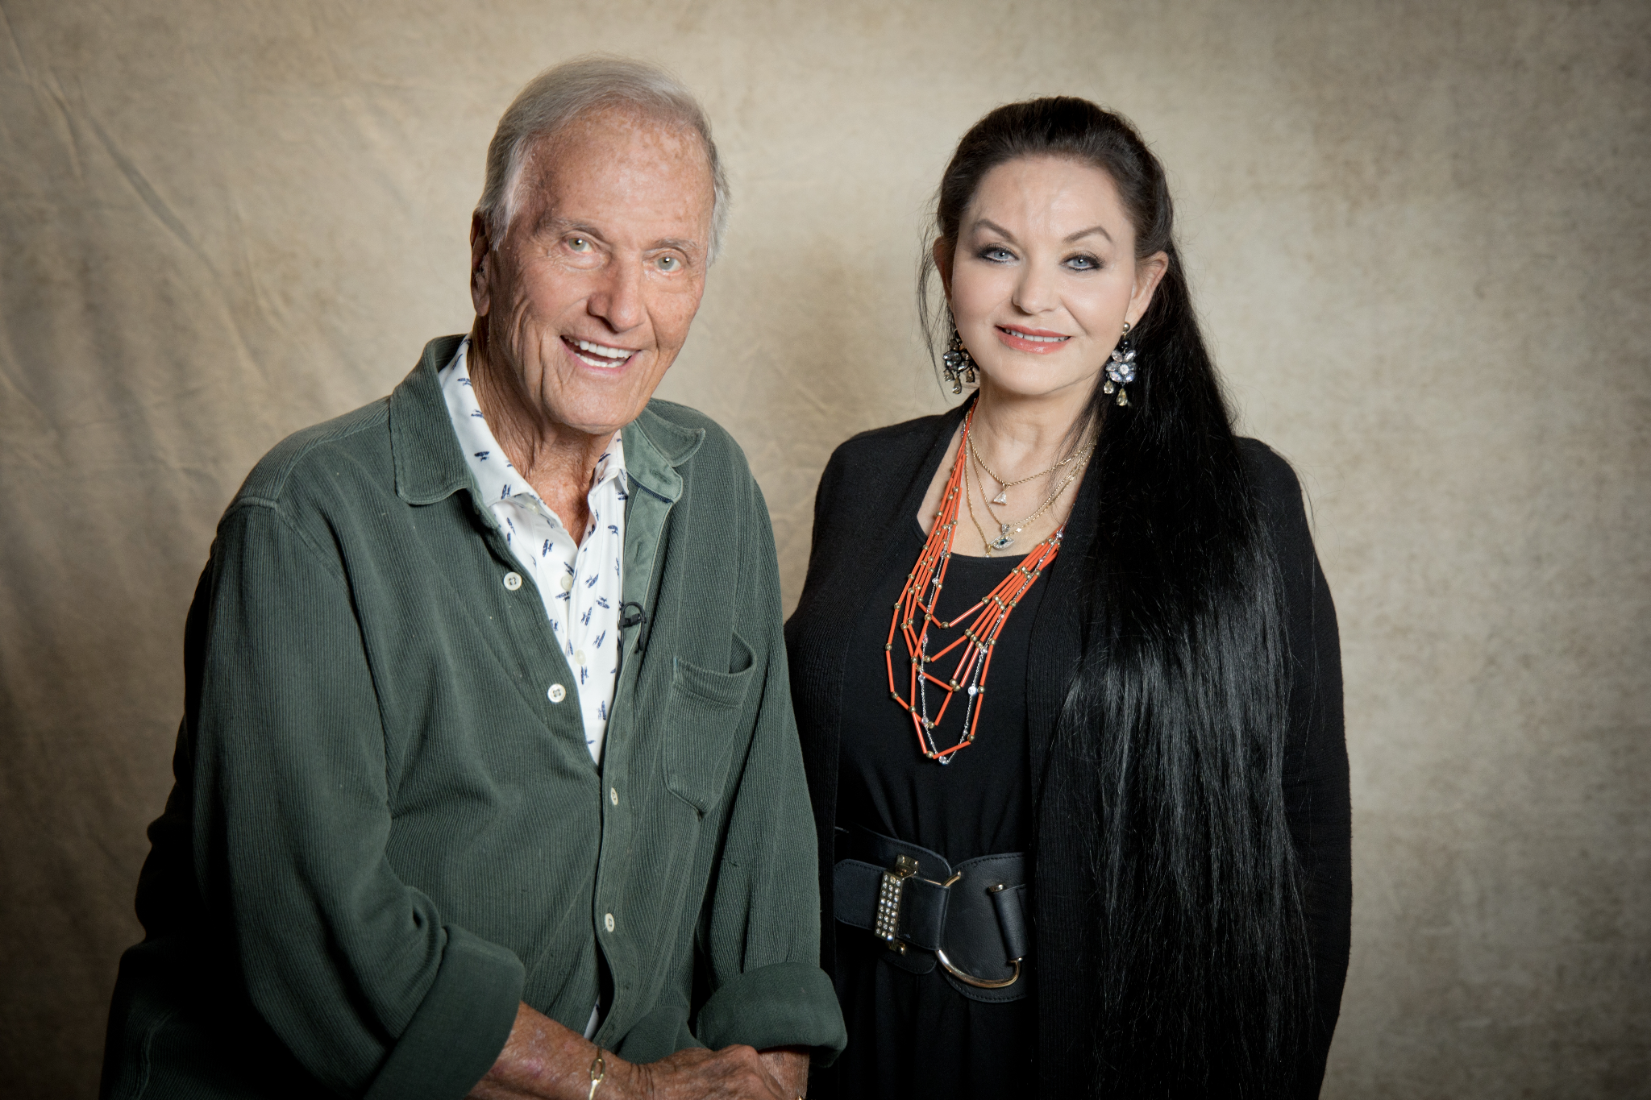
Photo Credit: Stacie Huckeba| Download Here

